Project Design Phase
Solution Architecture

Date
Student ID | 23NU1A4221
Project Name | Metro Ticket Generating System in ServiceNow
Maximum Marks | 2 Marks

Solution Architecture:
The Metro Ticket Generating System is designed using the ServiceNow Cloud Platform. Passengers use the Service Portal and Service Catalog to enter journey and ticket details. Catalog Client Scripts and UI Policies perform validation and dynamic form handling, while Business Rules and Flow Designer manage fare calculation and ticket processing. Ticket details are stored in ServiceNow custom tables, and a QR Server API generates the digital QR ticket, which is displayed through a Service Portal widget. Roles and ACLs provide secure access to the system.
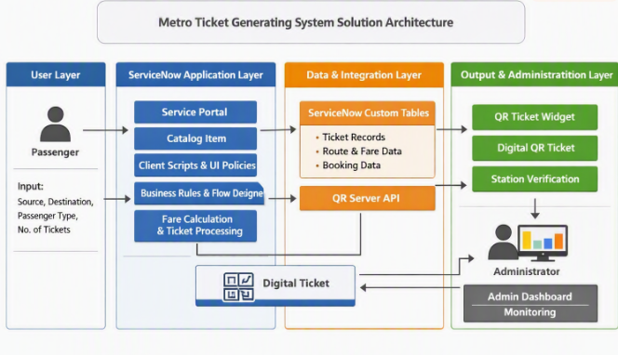
The Solution Architecture illustrates the end‑to‑end workflow of the Metro Ticket Generating System built on the ServiceNow Cloud Platform. It highlights how passenger inputs flow through the Service Portal and Catalog Item, are processed by client‑side and server‑side logic, stored in ServiceNow tables, and integrated with the QR Server API to produce digital tickets. The architecture ensures secure, automated, and scalable ticket generation with administrative monitoring and real‑time verification.

